# **MVP**

* Create a hardware that separates the common mode noise from the transceiver lines and connect it to the ADC pcb for further analysis.

# **Testing Methodology**

## **Simulation**

I’ll be using the following LTSPICE model and it is based on the research paper: [[Cited](https://ieeexplore-ieee-org.proxy.queensu.ca/document/6636501/references#references)]

## **Transceiver**

The representation of the SN65HVD23x 3.3-V CAN Bus Transceivers on the LTSPICE. <https://www.nxp.com/docs/en/data-sheet/TJA1040.pdf>

|  |  |  |
| --- | --- | --- |
| Electrical Characteristics: Receiver | | |
| Cin | Capacitance between CAN_H or CAN_L and ground | TYP value: 32 pF or 5pF |
| Cdiff | Differential input capacitance | TYP value: 16 pF or 10pF |
| Rdiff | Differential input resistance | Typ: 70kΩ or 25k |
| Rin | input resistance | Typ: 35 kΩ or 50k |

Figure Transceiver physical layer definitions

## **ESD Generator**

Electrostatic discharge (ESD) is a critical design and regulation assurance issues in modern electronic products, especially portable products including MP3 player, digital camera, camcorder and cellular phone. When an ESD occurs on an electronic product, a current is induced on the printed circuit board (PCB) within the product. This induced current can lead to malfunction of the product. [[Cited](https://ieeexplore-ieee-org.proxy.queensu.ca/document/4736014)]

The ESD generator or ESD gun simulates the electrostatic discharge for EMC testing. The components of the ESD gun are changed according to standards. For example, The IEC standard requires the ESD generator to apply a pulse of about 60 ns width through a 330Ω resistor and a 150-pF capacitor, producing a peak current of over 25 A for a 8 kV discharge. [[Cited](https://ieeexplore-ieee-org.proxy.queensu.ca/document/4736014)]

[IEC EN 61000-4-2](https://en.wikipedia.org/wiki/IEC_61000-4-2), Electromagnetic compatibility (EMC)- Part 4-2: Testing and measurement techniques - Electrostatic discharge immunity test.

[IEC EN 61000-4-3](https://en.wikipedia.org/w/index.php?title=IEC_EN_61000-4-3&action=edit&redlink=1), Electromagnetic compatibility (EMC)- Part 4-3: Testing and measurement techniques - Radiated, radio frequency, electromagnetic field immunity test. [[Cited](https://en.wikipedia.org/wiki/List_of_common_EMC_test_standards)]

Figure ESD based on IEC61000-4-2

## **IEC 61000-4-2**

The pictures below are from: [Cited](https://www.youspice.com/simple-spice-esd-generator-circuit-based-on-iec61000-4-2-standard/)

Figure IEC 61000-4-2 current wave characteristics

# **Design: Split Termination**

The waveforms with the single resistor termination show a larger magnitude of common mode transients during the switching transition, as well as a damped oscillation after the dominant to recessive transition. This damped oscillation is the result of the inductance of the line interacting with line and transceiver capacitance after the transceiver switches to its high impedance recessive state. [Cited](https://www.analog.com/en/technical-articles/can-bus-transceivers-operate-from-33v-or-5v-and-withstand-60v-faults.html). The damped oscillation can be canceled with a parallel capacitor on the transmission line to cancel the inductance of the line.

Muckecu current monitor

The corner frequency separates the common mode noise into low frequency and high frequency noise. This may provide better analysis of the noise.

**Design One: LISN**

**What is the purpose of the LINS and its operation?**

Conducted emissions are conducted via AC and can become radiated emissions when the network wiring or cabling operates as an antenna. To measure the conducted emission conducted out of an EUT (Equipment under test) a line impedance stabilization network (LISN) is used.

The three functions of the LISN are:

* Provide precise impedance to the power input of the EUT, to observe repeatable measurements of the EUT noise present at the LISN measurement point. The type of LISN depends largely on the induction of the power line connected to the EUT.
* Isolation of the power source noise. It basically acts as a low pass filter, and only a fraction of the noise is passed since the configuration is a voltage divider and prone to error.
* The spectrum analyzer or an EMI receiver is used to take the measurements during an EMC test, the input of this equipment is sensitive and the LISN helps by providing 50 ohms to the input of the analyzer.

References: [1](https://www.com-power.com/uploads/technote/Why_so_many_types_of_LISNs.PDF) [2](https://en.wikipedia.org/wiki/Line_Impedance_Stabilization_Network#cite_note-third-4) [3](http://www.unitest.com/pdf/LisnElec.pdf)

**Explain the schematic of a LISN­**

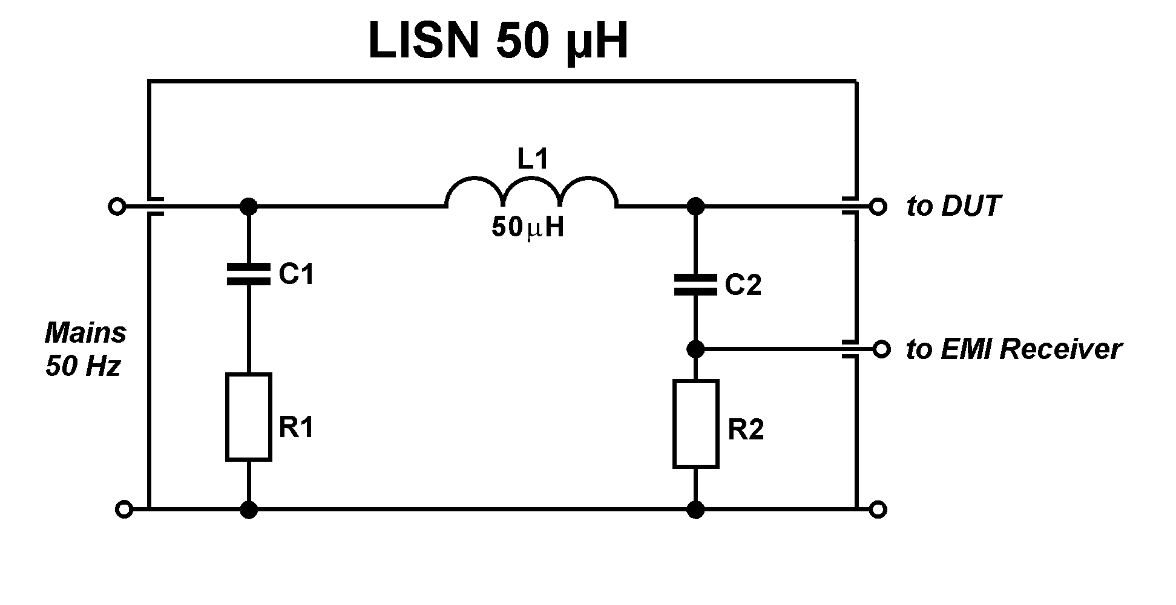

* The inductance of the power cable can be represented with an inductance value. The cable in automobiles are only a few meters (3 meters) and can be roughly represented with 5 microfarads.
* The C1 decoupling capacitor provides low local impedance in the LINS and isolates very high frequencies experiences from the cable inductance.
* The R1 dampens the LC filter and prevent resonance point.
* The C2 capacitor lets out only the AC noise out in the EUT and to prevent charge build up the R2 is added.

**LISN Design**

# **Background Information**

**What is common mode current?**

Common mode current is current that moves in the same direction in lines input and output. [Cited](https://www.youtube.com/watch?v=JQkNqY0I02Y).

The amount of noise present on the power line can be surprising at any given time. The source of this noise is from the electrical distribution system external to the building and from the one within the building. It is the result of the power line’s dynamic nature due to the ever-changing loads. [Cited](https://www.ti.com/lit/an/slla057/slla057.pdf?ts=1626807576986&ref_url=https%253A%252F%252Fwww.google.com%252F#:~:text=Common%20mode%20noise%20is%20often,with%20respect%20to%20analog%20ground.&text=The%20biggest%20source%20of%20common,between%20two%20physically%20remote%20grounds.)

Common mode noise is often referred to as common mode voltage (CMV) which is present at both input leads of an analog circuit with respect to analog ground.

**What causes common mode noise?**

It is caused by the EMI, RFI and ground loops: [Cited](https://www.ti.com/lit/an/slla057/slla057.pdf?ts=1626807576986&ref_url=https%253A%252F%252Fwww.google.com%252F#:~:text=Common%20mode%20noise%20is%20often,with%20respect%20to%20analog%20ground.&text=The%20biggest%20source%20of%20common,between%20two%20physically%20remote%20grounds.)

* Electromagnetic Interference (EMI) effects high-impedance circuits because they are susceptible to capacitive coupling from nearby circuits with rapid and large voltage swings and inductive coupling from nearby circuits with rapid changes in large currents. EMI may be radiated and can couple into the system through the metallic enclosures such as the chassis or through the data lines, a common being UTP wiring.
* Ground loops are different voltage levels at various grounds of supposed ‘ground value’ -[Cited](https://www.youtube.com/watch?v=PACur_GcTJ0), caused by inrush currents or fast switching.

Common causes of common mode noise:

* Ground loops are one cause of common-mode noise between phases, neutral and ground, in a power distribution system. This noise is inject into power supplies
* A poor ground system or an ungrounded analog signal cable can literally act as an antenna, gathering the induced voltage and applying it on the analog input.

**What are the properties of common mode noise?**

Common-mode noise impulses tend to be higher in frequency than the associated normal mode noise signal. This is to be expected since the majority of the common-mode signals originate from capacitively coupled normal mode signals [Cited](https://www.ti.com/lit/an/slla057/slla057.pdf?ts=1626807576986&ref_url=https%253A%252F%252Fwww.google.com%252F#:~:text=Common%20mode%20noise%20is%20often,with%20respect%20to%20analog%20ground.&text=The%20biggest%20source%20of%20common,between%20two%20physically%20remote%20grounds.)

However the common mode noise can range from low frequency to high frequency for that reason capturing the entire common mode signal allows for analysis of the entire noise

The common-mode waveform shows both types of noise: high-frequency noise corresponding to dominant-to-recessive/recessive-to-dominant transitions, and low-frequency noise corresponding to mismatched dominant and recessive common modes

[**https://www.pulseelectronics.com/wp-content/uploads/2021/01/Pulse-Power-BU-Understanding-Common-Mode-Noise.pdf**](https://www.pulseelectronics.com/wp-content/uploads/2021/01/Pulse-Power-BU-Understanding-Common-Mode-Noise.pdf)

